Blog post: Finding London Student Housing

Introduction

With the soaring cost of living in London, It is no surprise that 44% of students struggle to pay their rent each month [1] and 31 % finding their studies affected. Combined with increasing tuition fees, the crippling student debt crisis is a real problem in London and the rest of the UK. How can this keep going on? Now while attempts are being made to control rents through legislation [2]. However, this option is lengthy and unlikely to be successful, largely due to political opposition. So, it is our responsibility to seek more desirable housing to reduce students cost, to help the next generation with the continual goal of learning and improving themselves. As it is today's student that will become tomorrows inventors, business owners and professors.

Method

We do not have the perfect conditions for students to find affordable places to live in, but we do have access to vast amounts of data relating to the location of venues in London using the Foursquare API, the commute times using Google’s distance matrix API.

From the data, we can extract the ideal areas that students would live to live in, by looking at the number of and types of venues in each area. To determine the optimal location, we must first find acceptable boroughs, these are boroughs that are within a 45-minute commute of the university (King's College London).
To find ideal locations for students, areas will be clustered by venue and clusters will be compared to find the ones with the most ideal properties. Clusters with the most ideal areas will be extracted and rental prices will be compared to identify the areas where accommodation is affordable for students. Venue locations were determined using the search query in the Foursquare API. A K-mean algorithm was used to cluster the Boroughs by the type of venues in each Borough.

Results

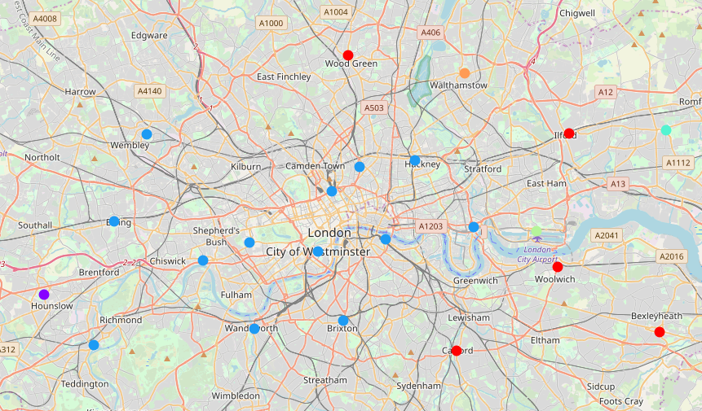Figure 1: Red - cluster 1, Purple - cluster 2, Blue - cluster 3, turquoise - cluster 4, Green - cluster 5, Orange - cluster 6. Clusters 1 and 3 were chosen to be the optimal boroughs. The map was created with Folium.

In Figure 1 we show the acceptable boroughs clustered by the different type of venues surrounding the boroughs. Only those clusters that were found to have the most ideal venues surrounding each borough, as they had the sorts of venues that would be ideal of students (shop, cafes, bars).

Discussion

From this analysis we have found the following boroughs to be ideal for students living in London: Bexley Greenwich, Brent, Camden, Ealing, Hackney, Haringey, Islington, Lambeth, Lewisham, Redbridge, Southwark, Tower Hamlets, Wandsworth, Westminster. These boroughs could be used as a guide to find affordable housing for students. Some of these boroughs are very well known among students, like Camden, but many are not, like Tower Hamlets, which has many rooms available in the £135 - £210 per week budget, even on the lower end.

Conclusion
As a whole, this project has been a success in finding affordable areas that would be suited to students. Especially in finding areas that are less well known, such as Tower Hamlets. This information could be used by students or housing organisations to find areas to rent in or to develop student accommodation.
Future work could attempt to quantify the cost of housing in each borough in Table 1, to find boroughs with the cheapest rents, whilst maintaining a useful number amenities. This would be essential to finding affordable accommodation. However, finding the cost of rent in each area is very difficult as there are many variables to consider when finding rooms to rent (e.g. size of room, en suite, shared or private). The difficulty lies in controlling the many variables across each boroughs, to make a like for like comparison. Some sort of averaging would have to be applied to factor in the large number of variables in renting a room.
In conclusion, the data analysis proved to be successful in find a number of areas that could be used or developed for student housing.

